**Recovery CD SOP**

1. **Install OS (XP Pro、Win 7 、Win 8.1、Win10 IoT ……).**

1.1 set BIOS to boot from CD-ROM.

1.2 Select Language**、Time format and KB input method &** next.

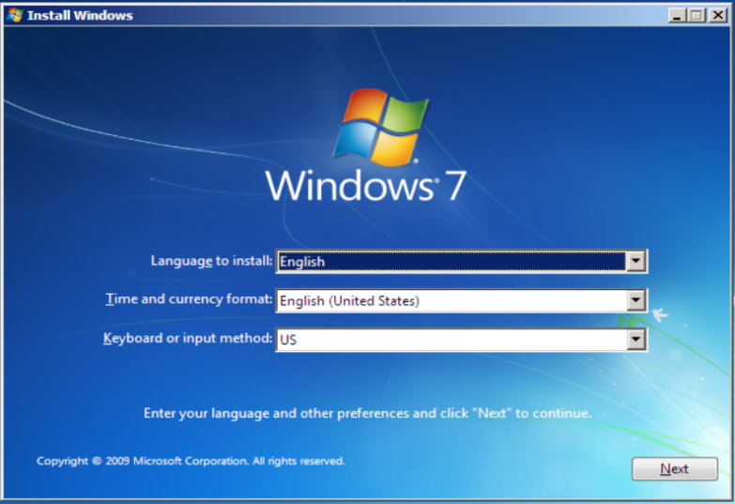

1.3 Install now.

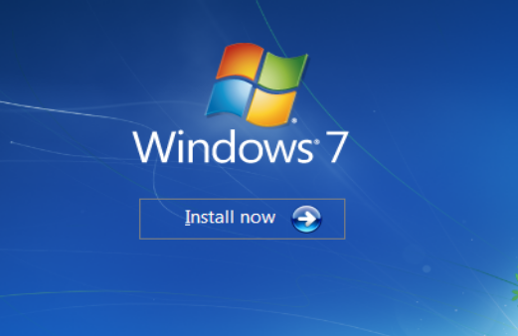

1.4 accept the license terms & next.

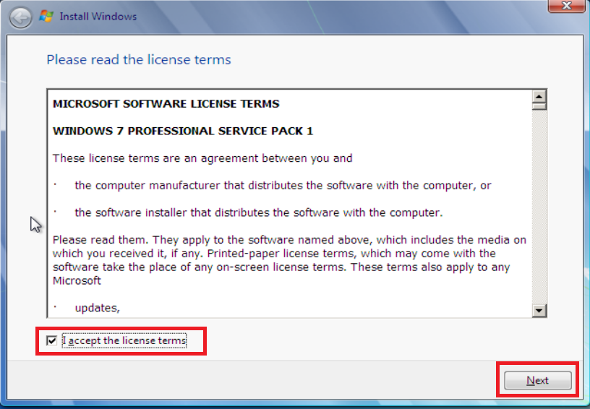

1.5 Custom (advanced) & next.

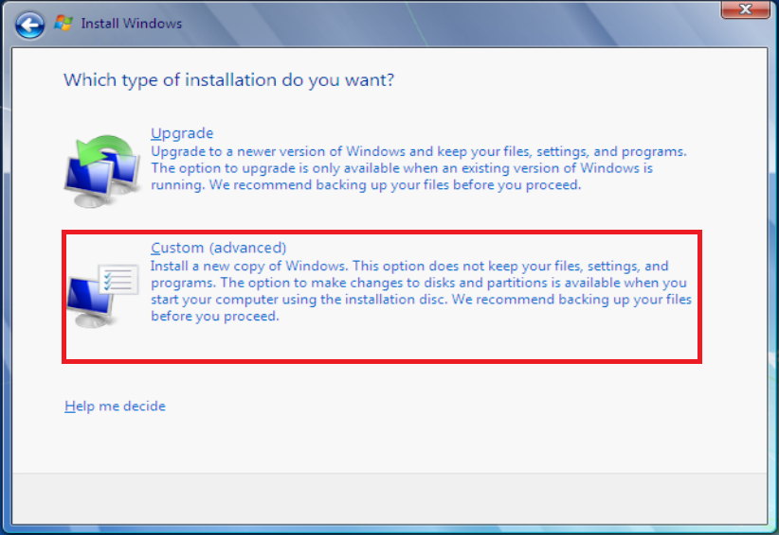

1.6 Partition the disk.

Press Shift+F10 to into command mode.

Commands

1. diskpart
2. list disk (check disk number)
3. select disk x
4. clean (erase all partition)
5. cre part pri (create new primary patition)
6. active (Set to bootable)
7. assign (Assigns a drive letter)
8. format quick fs=ntfs
9. exit

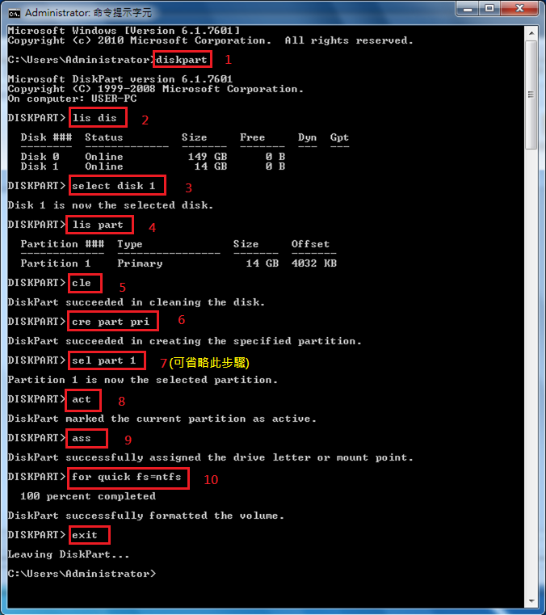

1.7 Drive options(advanced) & format & OK & next.

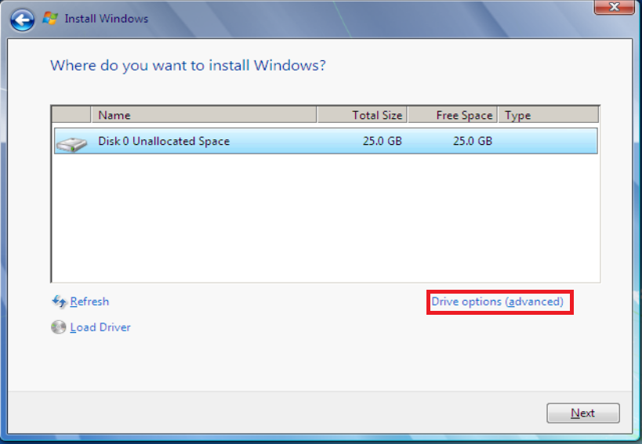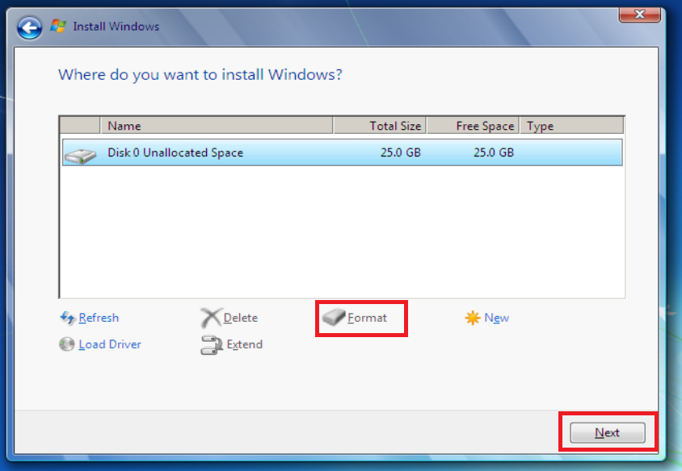

1.8 Reboot the PC 2 times.

1.9 Set up user name .

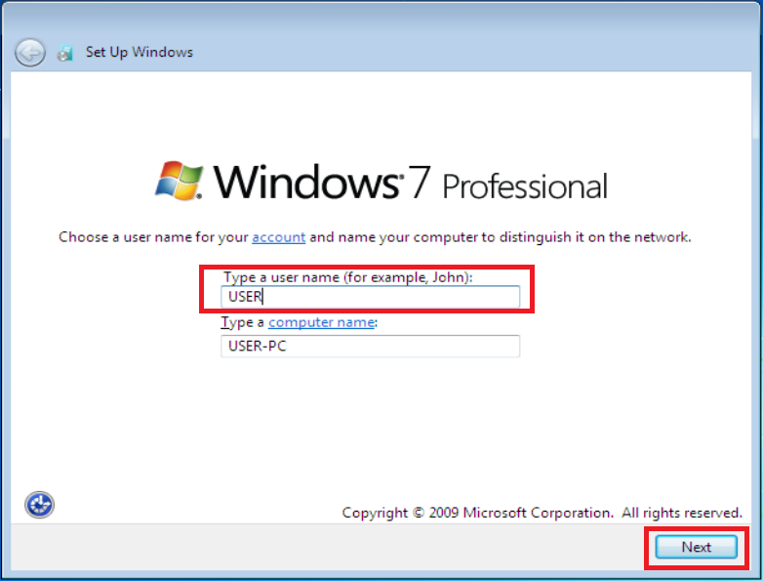

1.10 Set up password (default Set to empty).

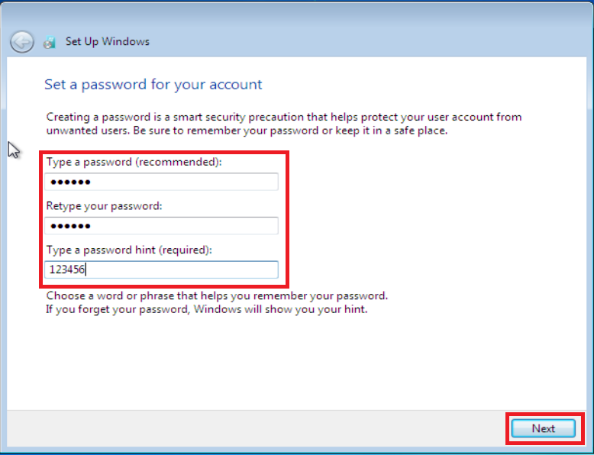

1.11 Set up PRODUCT KEY.

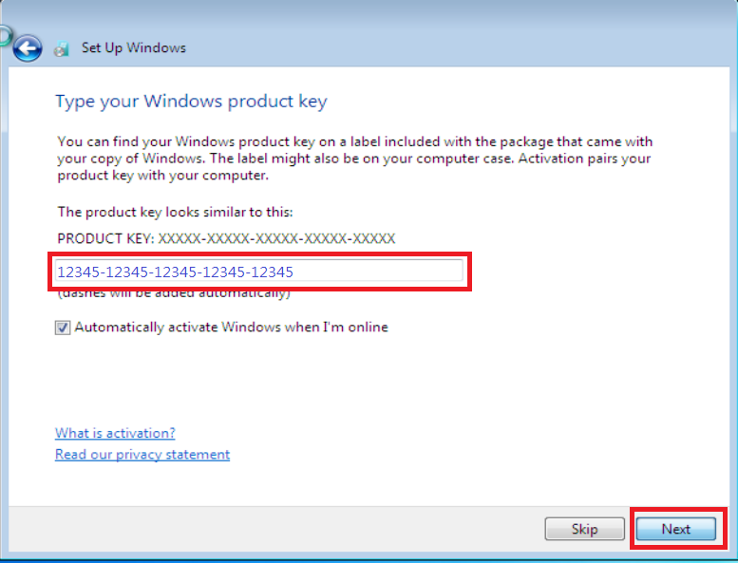

1.11 Set up security type.

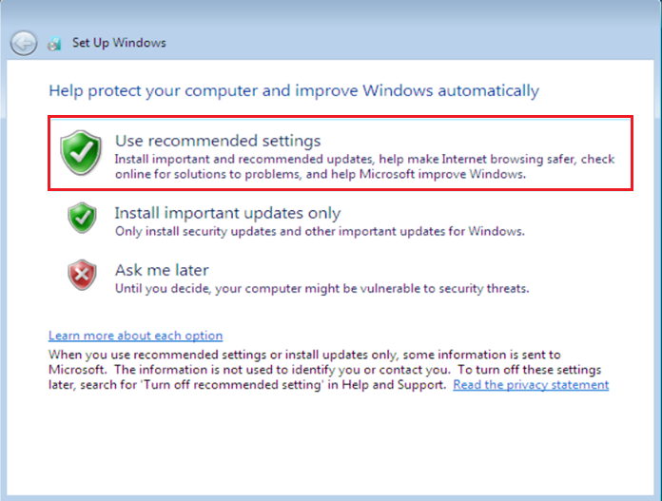

1.12 Set up Time zone & next.

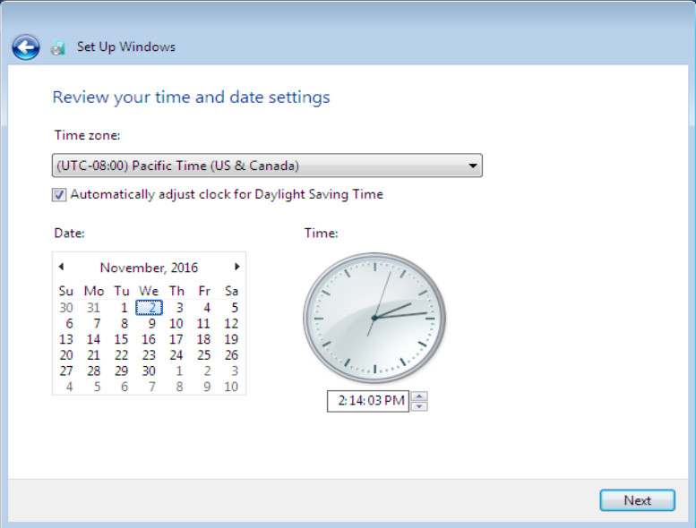

1.12 Boot up into OS.

1. **Enable administrator account (Win 7、Win 8.1、Win 10).**

2.1 Start 🡪 all programs🡪 Accessories🡪 Command Prompt 🡪run as administrator.

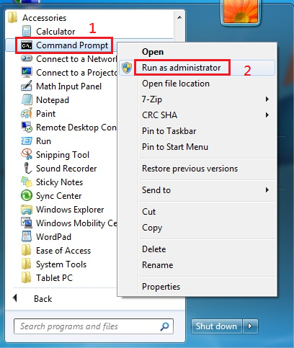

* 1. net user administrator /active:yes

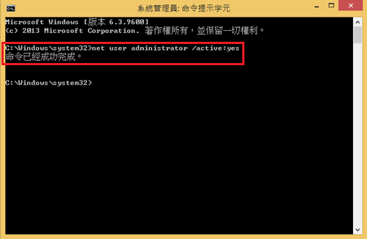

1. **Login off then login to administrator and remove test account.**

3.1 Start 🡪control panel 🡪Add or remove user accounts.

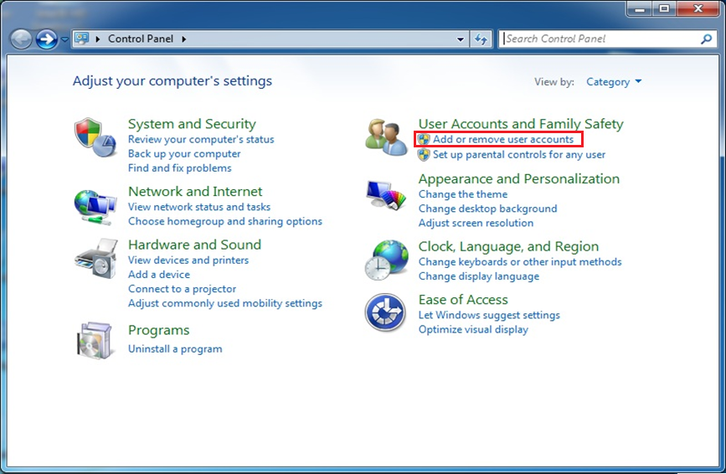

3.2 Select test account.

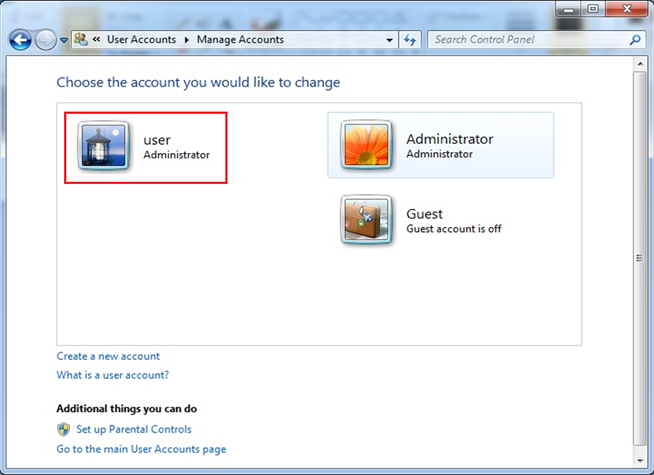

3.3 Delete the account🡪 Delete Files🡪 Delete Accounts.

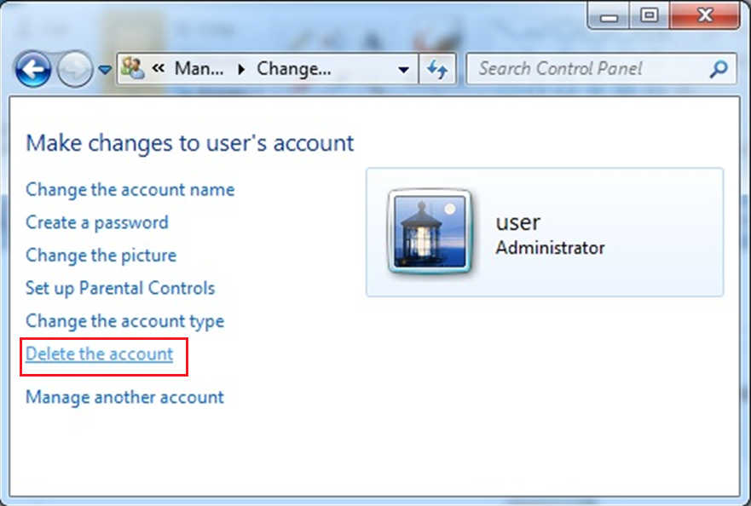

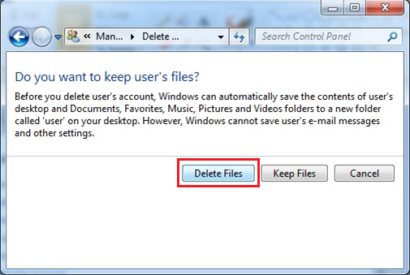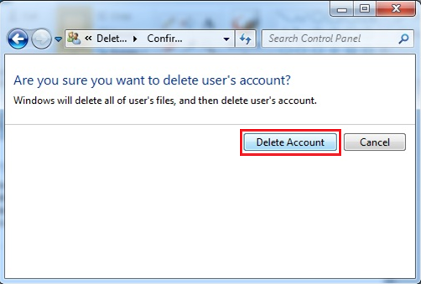

1. **Install device driver. (Chipset, Graphic, Network, Audio, Others……)。**

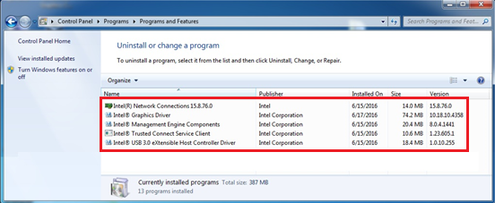

1. **Check Device Manager**

5.1 My computer 🡪Manager🡪Device manager

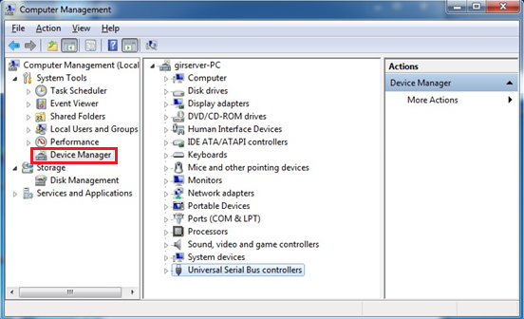

5.2 Test I /O Function (USB, COM Port, LAN Port, Audio……).

1. **Put SN txt file in C:\windos\.**

6.1 Enable “show hidden files. Folders. And drivers”

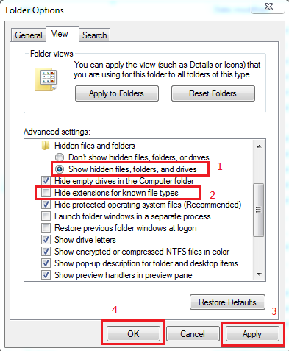

6.2 Copy SN file to c:\winodws\ then set to read only and hidden.

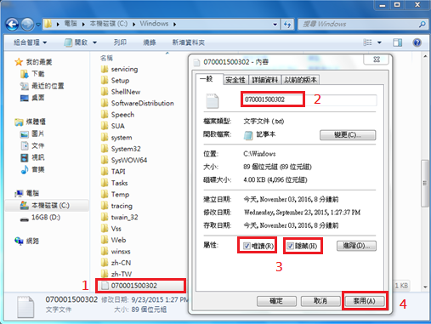

6.1 Disable “show hidden files. Folders. And drivers”.

6.4 Reboot then back up OS by ghost32.exe.

1. **Use win PE USB disk with ghost to back up OS.**

7.1 Set BIOS to boot from USB HDD.

7.2 Shift+F10 into command mode and run e:\ ghost32115.exe。

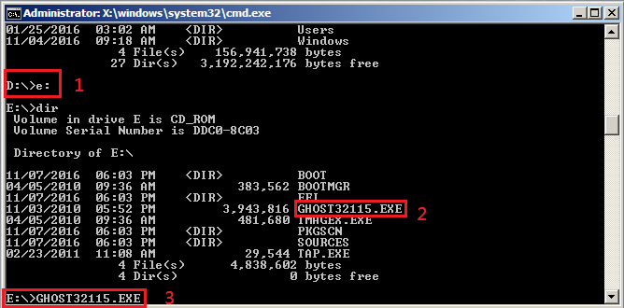

7.3 Local🡪 Disk🡪To Image.

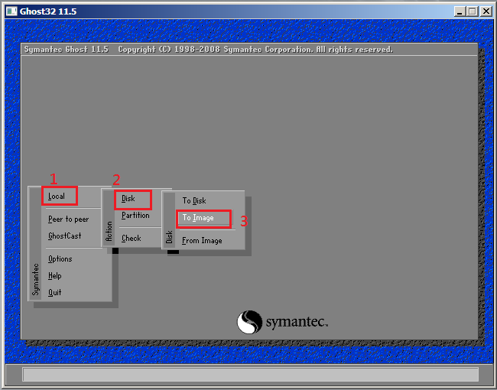

7.4 Select Source Drive 🡪OK。

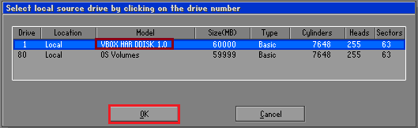

7.5 Save。

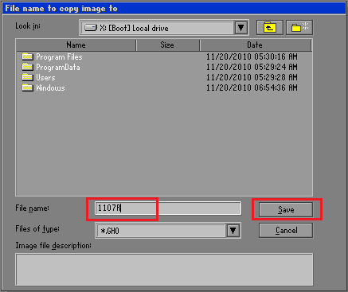

7.6 Use compression = high 🡪 Yes。

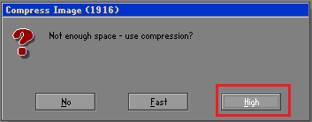 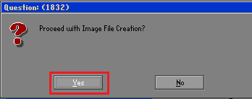

7.7 Start back up OS.

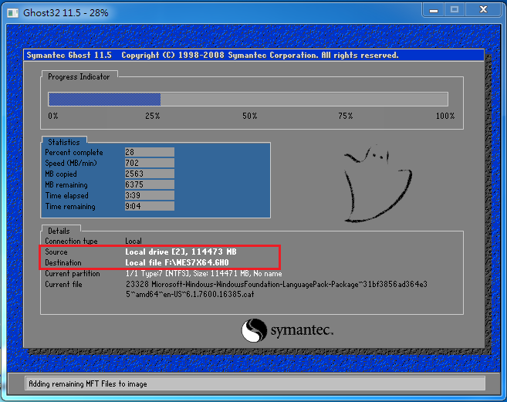

7.4 Exit Ghost APP then remove USB HDD and reboot PC.

1. **Language change (win10x64)**

8.1 select Language you need

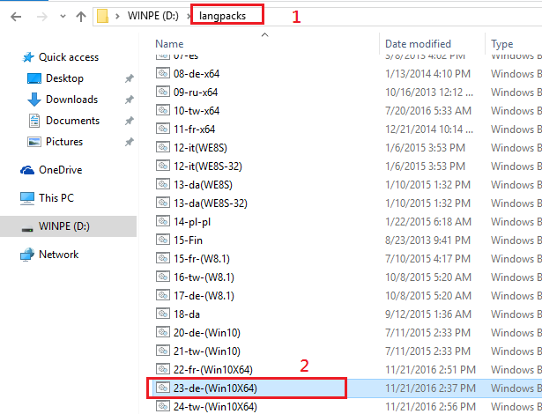

8.2 Adding language package then use delEng.reg to remove English language package.

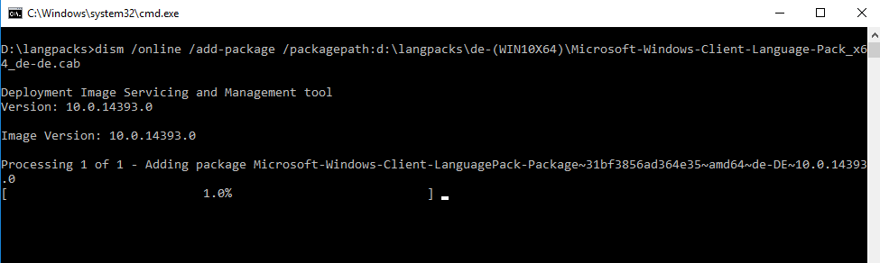

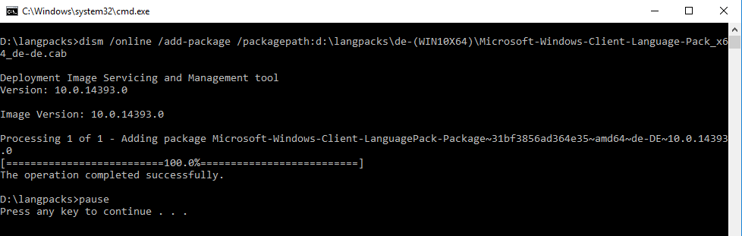

8.3 Control Panel → Add a language

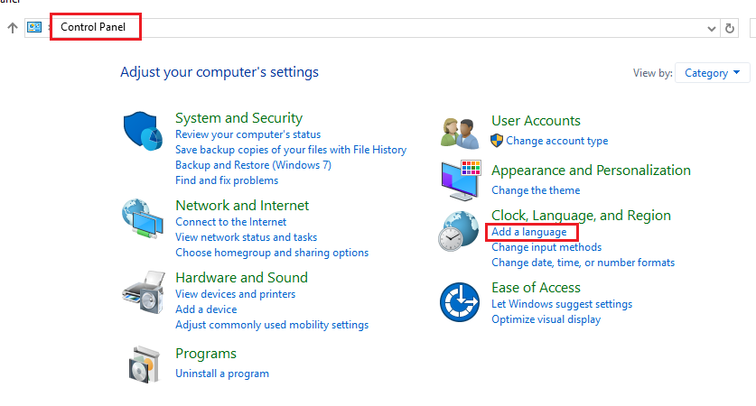

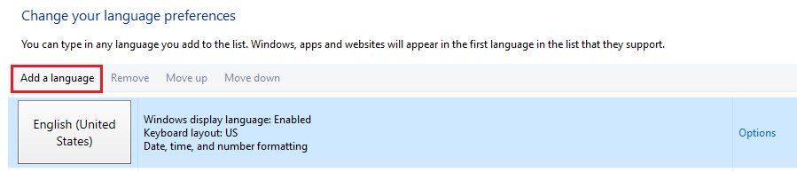

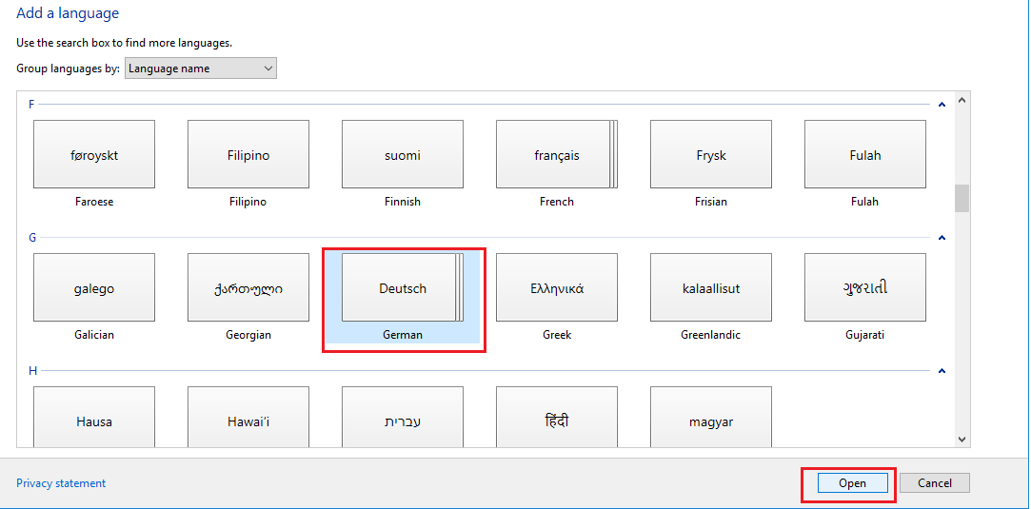

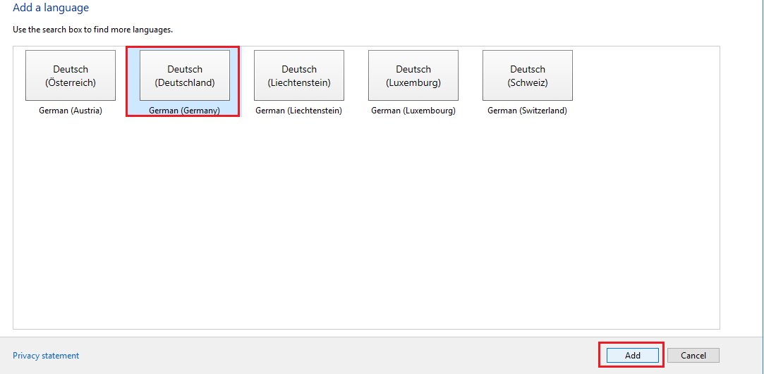

8.4移除英文語系→並且重新開機→確認是否更改成功。

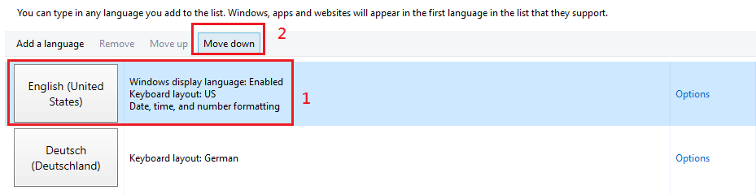

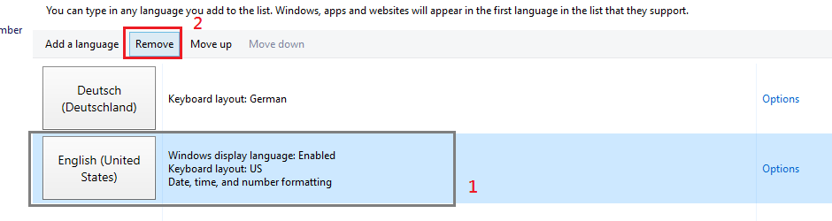

8.5重新開機後若語言還是英語，再進入此畫面，手動設定。

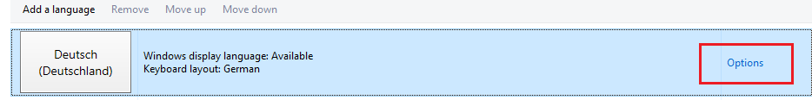

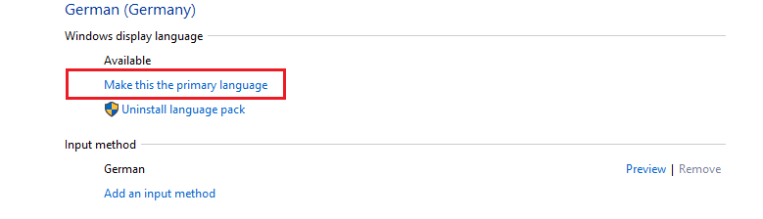

8.6 Reboot PC then check Language has be changed.

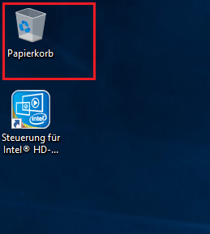

1. Use System Preparation Tool(sysprep.exe) **。**

9.1 32bit OS (Windows sysprep.exe or Aplex sysprep tool)

9.1.1 Run c:\windows\system32\sysprep\sysprep.exe.

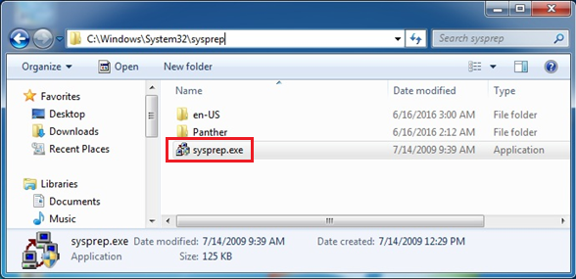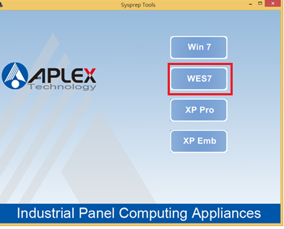

9.2 64bit OS

9.2.1 Use x64 sysprep batch: run copytosys.bat.

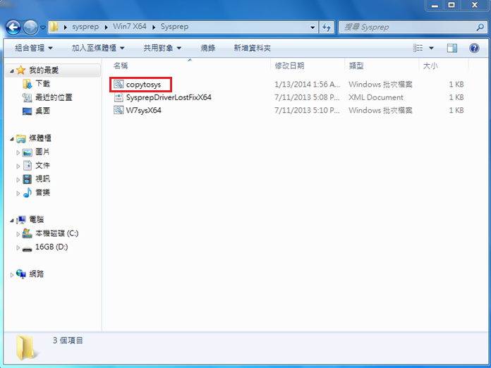

9.2.2 Run c: 🡪window🡪system32🡪sysprep🡪w7sysX64.bat.

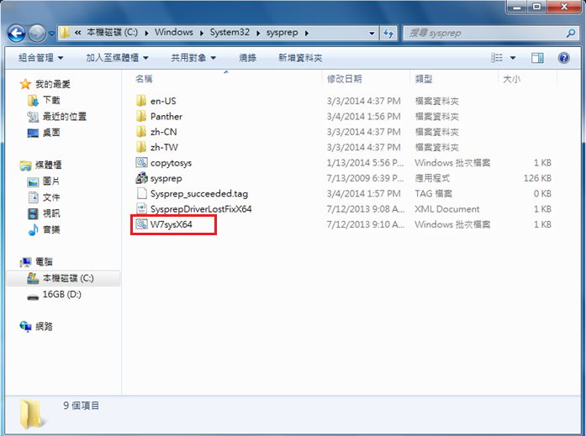

* + 1. Auto shutdown.

1. **Boot from WinPE USB HDD, back up OS to WIM file.**

10.1 Set BIOS to boot from USB HDD.

10.2 Shift+F10 to open command mode

10.2.1 d: 🡪 cd we10PID🡪 we10_LTSB_Value.bat

(Win10 IoT has three types =>Entry, Value, High end)

10.2.2 imagex8.exe /capture c: d:\070071110301.wim “EngRes”

(Capture c: to d:\ 070071110301.wim and set tag = EngRes)

imagex8.exe /append c: d:\070071110301.wim “FraRes”

(Capture c: to same WIM file and set different tag = FraRes)

1. **Use UltraISO to make CD ISO file.**

11.1 Install UltraISO.

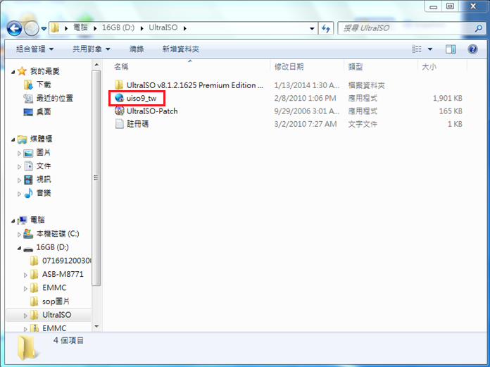

11.2 Copy an ISO file from “X:\” which be a template

11.3 Open ISO file by UltraISO.

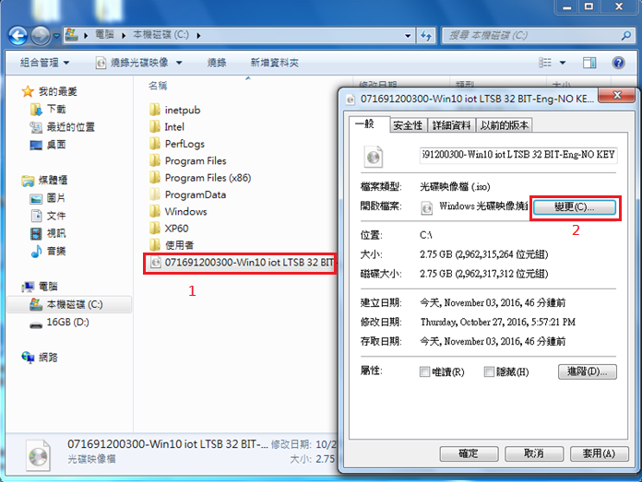 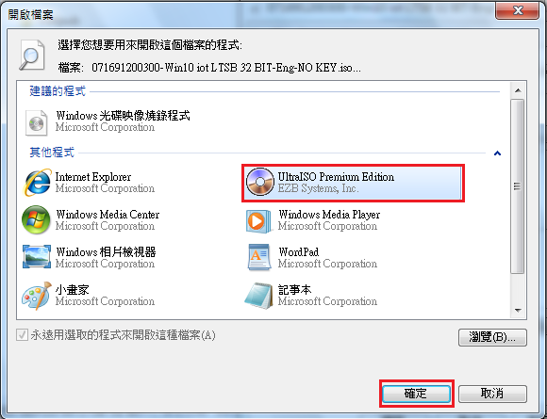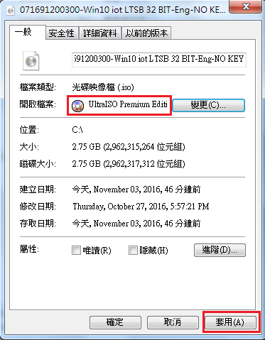 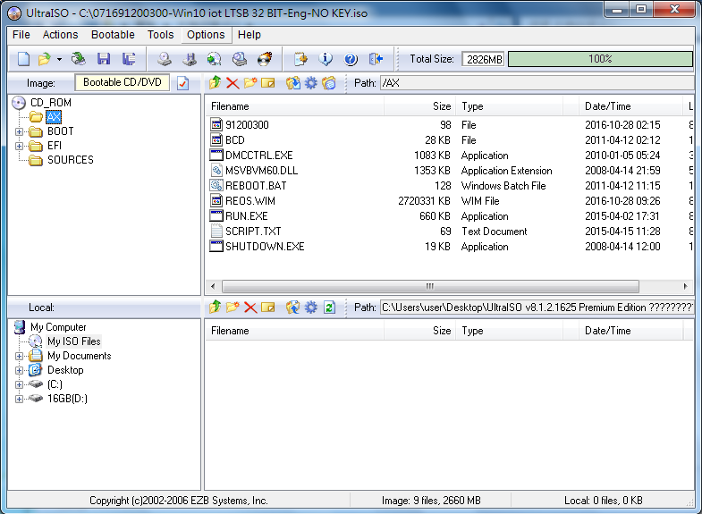

11.4 Replace the WIM file in the AX folder and naming to “REOS.WIM”.

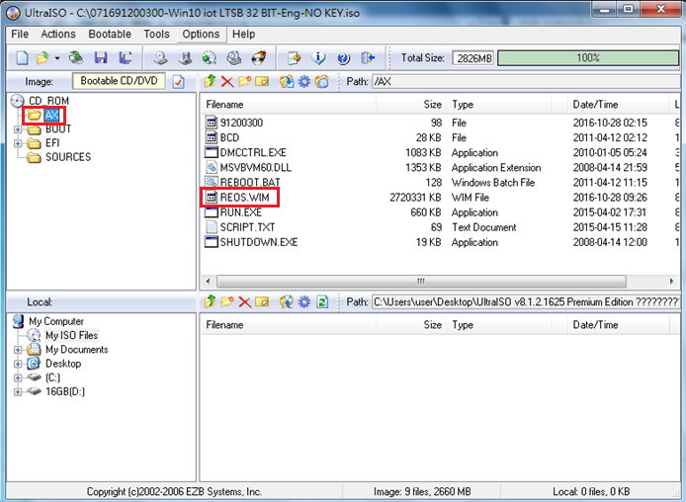

11.5 Replace the SN file (Can only have eight words) & RUN.exe.

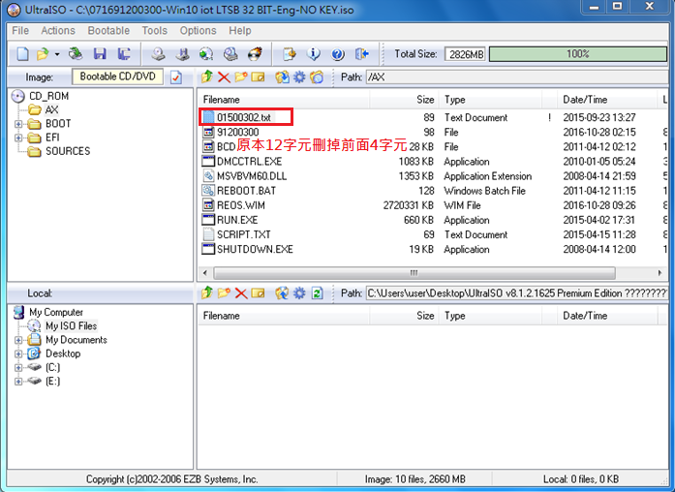

11.6 run.exe

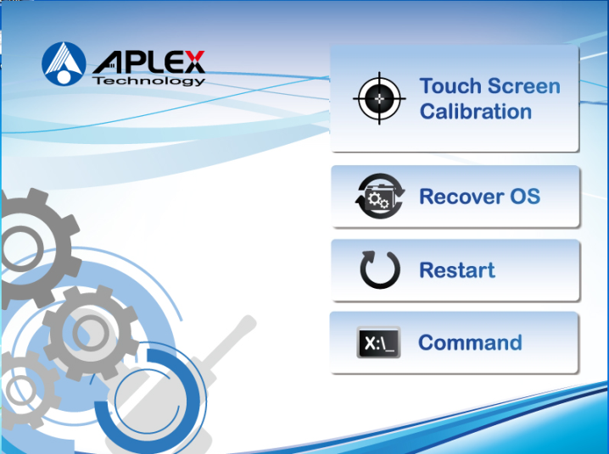

11.7 Save changes and burn to CD/DVD.

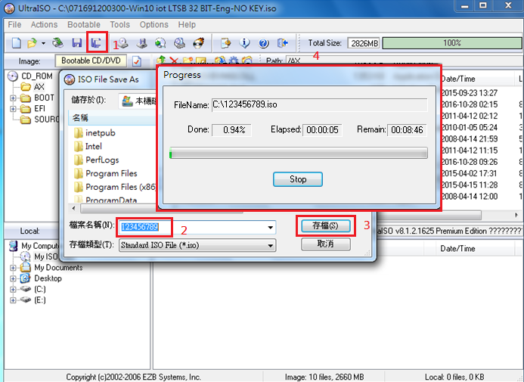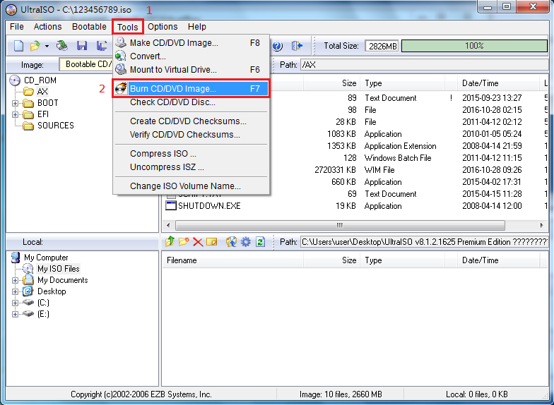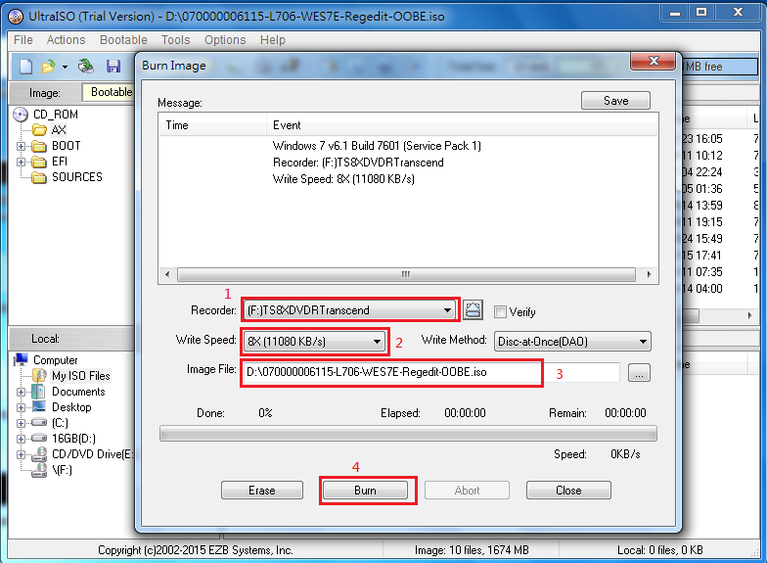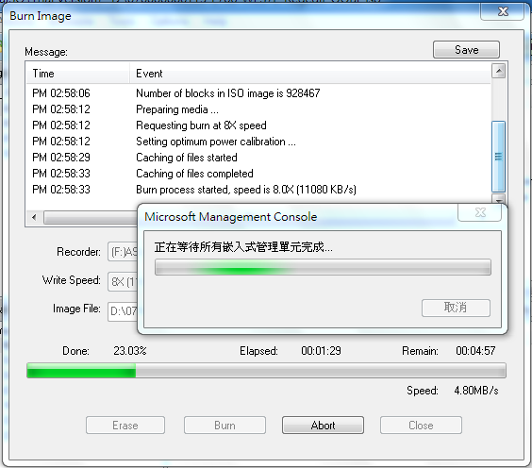

11.8 Set BIOS to boot from CD-ROM and Recover OS.

